臺北市立大學資訊科學系碩士論文

指導教授：壽大衛 博士

DApp 伺服器架設與組態自動化劇本開發 Ansible Playbook Development for Automating DApp Server Setup and Configuration

研究生：郭怡廷 撰

中 華 民 國 1 1 0 年 0 4 月 1 4 日





Ansible Playbook Development for Automating DApp Server Setup and Configuration

by

Yi-Ting Kuo

Advisor

A. P. Ta-Wei Shou

A thesis submitted to

the Department of Computer Science at

University of Taipei Taipei City, Taiwan 100

in partial fulfillment for the requirements of

the Master of Science Degree Program, June 2021



©Copyright By Yi-Ting Kuo 2021 All Right Reserve

臺北市立大學資訊科學系

碩士學位論文



Ansible Playbook Development for Autmnating DApp Server Setup and Configuration



$ 4-JU A: Jl <i

* 4- : *:$:7*

i * *#t* : *-r, 4!]*



Ansible Playbook Development for Automating DApp Server Setup and Configuration



**Acknowledgement**

The author wishes to express her deepest appreciation to her thesis advisor, A. P. Ta-Wei (David) Shou, for his inspiration and guidance throughout the course of this work.

The author would also like to express her gratitude to Prof. John Kun-Han Li, Prof. Chung-Hsin Liu for their valuable suggestions, Mr. Nicholas Francis Haggerty, and Miss Tarn Parker for their help with proofreading.

Finally, the author must express her very profound gratitude to her parents and for providing her with unfailing support and continuous encouragement throughout her years of study and through the process of researching and writing this thesis. This accomplishment would not have been possible without them.

Yi-Ting Kuo



# Abstract

Most of the transaction media we use in short-term events, such as tokens used in school fairs or coupons, are often time-consuming, resource-wasting and labor- intensive to make. The transaction mediums lose their value soon after the event is over, which is not cost-effective. The present paper uses design science research to propose a business process structure of using Hyperledger Fabric to track transactions for short term events, and takes a further step to develop an Ansible playbook for automatically setting up DApp servers and configuring a HAproxy server for load balancing. The designed Ansible playbook results in setting up the servers within 37 seconds, and automatically scaling up to add a new server within 42 seconds in case of emergency.

#### Keywords: Blockchain, Ansible, Automation, Hyperledger Fabric, DApp, Design Science Research

## 摘要

現今多數短期展覽中，使用像是園遊會代幣或兌換券的交易媒介，通常需耗費大量人力、物力與時間等資源製造，卻在活動結束後隨即失去價值，並不符合製造成本效益。本研究嘗試使用設計科學研究提出一套可行的超級帳本交易流程框架，記錄並追蹤短期展覽中發生的交易與商品流向，並進一步開發 Ansible 劇本自動化分散式應用程式伺服器架設與組態以及實現負載平衡。本研究所撰寫之劇本於 37 秒內完成包含負載平衡之原始架構的伺服器架設與組態，並能在緊急狀況下，於 42 秒內自動架設組態完成一台新的主機加入服務。

**關鍵字：區塊鏈、Ansible、自動化、超級帳本、分散式應用程式、設計科學研究**

# Table of Contents

Acknowledgement i

Abstract 3

摘要 4

Table of Contents 5

List of Figures 7

List of Tables 9

Chapter 1 Introduction 1

1.1 Motivation and Purpose 1

1.2 Research Limitation 2

1.3 Thesis Organization 3

1.4 Glossary of Terms 4

Chapter 2 Literature Review 7

2.1 Blockchain 7

2.2 Ansible 13

2.3 Docker 16

2.4 DApp User Interface 19

2.5 HAproxy 20

2.6 Design Science Research 21

Chapter 3 Research Methods 23

3.1 Design of the Structure 23

3.2 Experiment Testbed Architecture 23

3.3 Evaluation Tool 26

3.4 Monitoring Tool 28

Chapter 4 Results 31

4.1 Server Monitoring 31

4.2 Designed Ansible Playbook 33

4.3 Evaluation 40

Chapter 5 Conclusion 51

References 55



# List of Figures

Figure 1.1 Thesis Organization 3

Figure 2.1 Famous Examples of Blockchain 1.0 to 3.0 7

Figure 2.2 Projects Under the Hyperledger Namespace 9

Figure 2.3 A Fabric network with federated MSPs and running 10

Figure 2.4 Example of an Ansible Playbook 14

Figure 2.5 Schematic Diagram of Containerized Applications 16

Figure 2.6 Relations between Images, Registries, and Docker Files 17

Figure 2.7 An Example of Load Balancing 20

Figure 3.1 The Testbed Architecture of Experiment 24

Figure 3.2 Information of the Experiment Testbed Architecture 24

Figure 3.3 The Experiment Testbed Load-balancing Architecture 25

Figure 3.4 Example Output of Apache Benchmarking Tool 27

Figure 3.5 Dashboard of the Zabbix Server 29

Figure 4.1 Example of the Telegram Alert 32

Figure 4.2 The State of Existing Webservers and the Load-balancer 33

Figure 4.3 The Ansible Configuration File 34

Figure 4.4 The Shell Script “newWebserver.sh” 35

Figure 4.5 The Structure of the Designed Ansible Playbook 36

Figure 4.6 The Results of Curl Hostc and Hostd 37

Figure 4.7 The Results of Curl Hostb 37

Figure 4.8 The Content of Ansible Playbook “prepHAproxyAndWebservers.yml” 38

Figure 4.9 The Content of Ansible Playbook “installZabbixAgent.yml” 39

Figure 4.10 The Evaluation of the Web Servers 41

Figure 4.11 The State of Servers while Operating Evaluation Testing 42

Figure 4.12 The Time Consumption of 30 Evaluation Tests 42

Figure 4.13 The Full Run of Ansible Playbook “prepHAproxyAndWebservers.yml” 44

Figure 4.14 The Full Run of Ansible Playbook “installZabbixAgent.yml” 45

Figure 4.15 Host Remains Unchanged if It Already Meets the Desired State 46

Figure 4.16 The Full Run of Ansible Playbook to Set-up a New Webserver 46

Figure 4.17 Installing Zabbix Agent on the Newly Configured Server 47

Figure 4.18 The New Test-bed Architecture after Adding in Hosta 48

Figure 4.19 The Time Consumption of Setting up a New Webserver 48

Figure 5.1 Deployment Process 53

Figure 5.2 Flow Chart of the Experimental Architecture 54

# List of Tables

Table 2.1 Tool Modules of Hyperledger Fabric 12

Table 2.2 Design-Science Research Guidelines 22

Table 4.1 Results of Two Webservers Completing 62,800 Requests with 1,000 Hits 43

Table 4.2 Time Consumption for Setting up a New Server 49

Table 5.1 Responsibility Determination between Human and Machine 52



# Chapter 1 Introduction



### Motivation and Purpose

After the community fulfilled the Bitcoin system based on the thesis Satoshi Nakamoto published in October 2008, Blockchain technology has been developed rapidly and used in diverse fields, yet there are still not a great deal of applications of Blockchain technology for short-term events. Most of the transaction media we currently use in short-term events currently, such as tokens at school fairs or redemption coupons, are often time-consuming, resource-wasting and labor-intensive to make. Additionally, the transaction mediums soon lose their value once the event is over, which is against cost-effectiveness. A possible solution to this issue is using Blockchain Technology to keep record of the transactions happening during the events.

The present paper uses design science research to propose a business process structure of using Hyperledger Fabric to track transactions for short-term events, using Taipei International Travel Fair (ITF) as an example, and takes a further step to develop an Ansible playbook for automatically setting up DApp servers and configuring a HAproxy server for load balancing.

### Research Limitation

The present paper aims for creating an Ansible playbook prototype for setting up and configure the servers for short-term events. Therefore, the present paper uses the Taipei International Travel Fair in 2019 as an example to design the playbook since it has a more integrated data. The possible future work directions are discussed in the conclusion section.

The time used for developing and testing the DApp user interface, configuring Ansible remote users on each machine, and the setup of the Zabbix monitoring server is not recorded within the tables, and the time required for a full run of the Ansible playbook depends on the speed of the internet, program dependencies, and the state of the servers.

### Thesis Organization

The present paper is divided into five chapters, starting with an introduction of research motivation and purposes, thesis organization, and glossary of terms. The second section is a literature review and related works, covering the topics of Blockchain, Ansible, Docker, DApp user interface, HAproxy, and design science research. The third chapter, research methods, covers how the design of the present paper follows the seven design science research guidelines, this section also includes the testing environment setup and the benchmarking tools used to evaluate the performance, together with the monitoring tools used in this thesis. The fourth section covers the results - a Zabbix server for monitoring purposes, the designed Ansible playbook, and the evaluation of the servers. The fifth chapter is the conclusion.

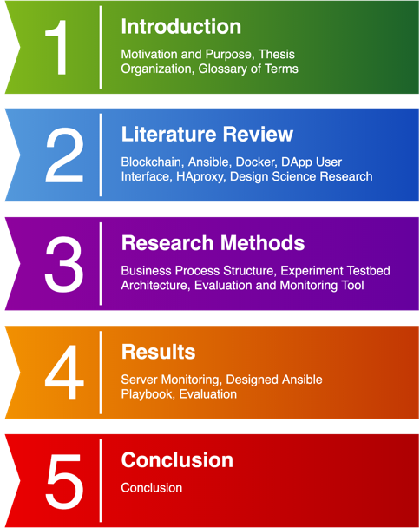

*Figure 1.1* Thesis Organization

### Glossary of Terms

Apache Benchmarking tool (AB):

A tool for benchmarking Apache HTTP Servers.

Black-box Monitoring:

Unlike white-box monitoring, black-box monitoring is often phenomenon based, meaning that it describes the problems as they are happening.

Chaincode:

Equivalent to smart contract in blockchain 2.0, chaincodes define the rules of transactions.

Docker Hub:

The largest public registry for docker images currently.

Load Balancing (LB):

A technology to prevent out of service by distributing requests onto different servers.

Permissioned Blockchain:

Similar to the idea of membership. Permissioned means the participants in such a blockchain are known. Hyperledger Fabric is one of the famous examples of permissioned blockchain.

Permissionless Blockchain:

Unlike permissioned blockchain, a permissionless blockchain system does not require participants to reveal their identity. It takes advantage of its anonymity and transparency while it gets bulkier and slower as the blockchain keeps growing.

White-box Monitoring:

White-box monitoring are often the data collected within the system. It is often used to predict problems that are going to happen.



# Chapter 2 Literature Review

The literature review contains topics related to the present paper, starting with a brief introduction of blockchain and Hyperledger Fabric, followed by main concepts of Ansible, Docker, DApp user interface, HAproxy, and the design science research.

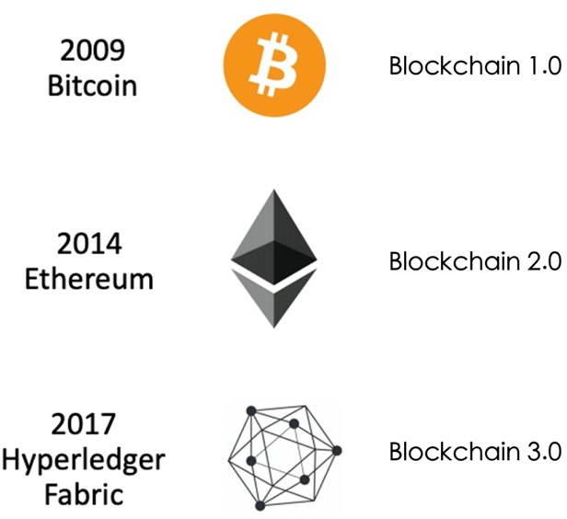

### Blockchain

After the community fulfilled the Bitcoin system based on the thesis Satoshi Nakamoto published in October 2008, Blockchain technology has been developed rapidly and used in diverse fields. The development of blockchain can be roughly separated into three phases, blockchain 1.0, 2.0, and 3.0.

*Figure 2.1* Famous Examples of Blockchain 1.0 to 3.0

The origin of blockchain 1.0 is of course Bitcoin. It was a hard-coded cryptocurrency application with limited stack-based scripting language. Traits of blockchain 1.0 are it is a permissionless blockchain system with native cryptocurrency which really relies on its proof-of-work consensus and the Sybil-control mechanism. As time passes, Bitcoin is becoming much bulkier and slower, making it irrelevant to modern transactions that require fast-paced authentications.

Blockchain 2.0 made a huge development base on the fundamental traits of blockchain 1.0. Other than having its own native cryptocurrency, its new feature, smart contract, broadens the possibilities of blockchain beyond only being a medium to trade. With the combination of distributed applications and smart contracts, Ethereum can apply to more financial scenarios. One shortcoming of blockchain 2.0 is the smart contracts request to be composed in a domain-specific language, like Solidity for Ethereum.

Taking a further step from blockchain 2.0, blockchain 3.0 opens up broader fields for blockchain applications. Ranging from identity authentications, notarization, arbitration, auditing to medication, the transaction can be more free form compared to the rigidity in either Bitcoin or Ethereum. One of the most famous and popular examples of blockchain 3.0 is Hyperledger Fabric, a permissioned blockchain system. Its chaincode feature is equivalent to smart contracts in blockchain 2.0. It can be composed in many general-purpose languages (e.g., Java, Golang). Unlike blockchain

1.0 and 2.0, blockchain 3.0 uses modular – so called “pluggable consensuses,” enabling it to be faster and more light-weight. Hyperledger Fabric does not come with a native cryptocurrency, yet it is an upcoming feature the public is looking forward to developing in the near future.

* + 1. Hyperledger Technology

Hyperledger Fabric is an opensource permissioned Distributed Ledger Technology (DLT) platform (Hyperledger, 2020). It is highly modular and contains multiple ledgers that can track any kind of cross-industry asset.

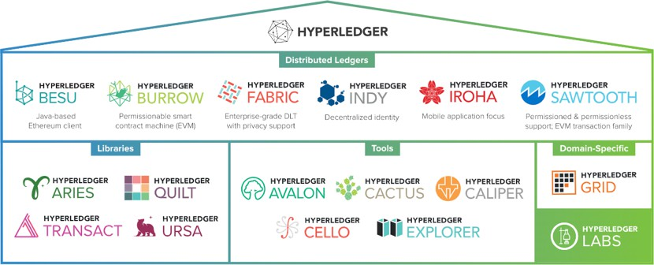

*Figure 2.2* Projects Under the Hyperledger Namespace1

Hyperledger was designed particularly to target cross-organizational enterprise applications, therefore, a Hyperledger Fabric transaction can be far more free form compared to the rigidity in either Bitcoin or Ethereum. For example, we can capture any piece of information we want, such as names and emails, based on different use cases (C. Gorenflo, S. Lee, L. Golab and S. Keshav, 2019).

From a business perspective, many traits of public blockchains, like anonymity and full transparency, are not desirable qualities since the businesses need to know who the users are and make sure specific information is only revealed to certain groups of

1 Adapted from “Use: Install, build and deploy solutions using Hyperledger technologies,” by The Linux Foundation, 2020. Copyright 2020 by “The Linux Foundation”, https://[www.hyperledger.org/use.](http://www.hyperledger.org/use)

people. With a feature in Hyperledger called “Channels, ” enterprises are able to create multiple ledgers with a unique set of permissions. Every channel comes with its own ledger, a space to store chaincodes and a set of permissions, preventing any attacker from possibly obtaining a “God-Mode View.” Only the contents that are relevant to the members would be broadcast on particular channels. A channel can have multiple owners.

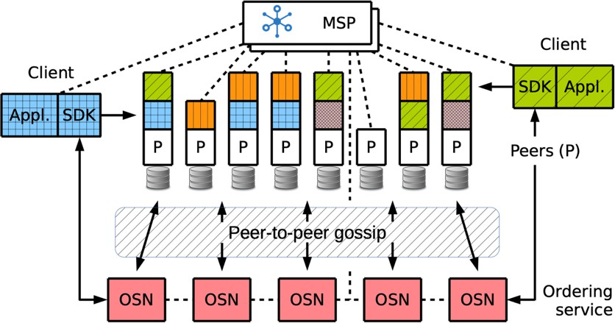

*Figure 2.3* A Fabric network with federated MSPs and running multiple chaincodes, selectively installed on peers according to policy2

A pluggable component of a Hyperledger Fabric Network for identity control called “Membership Service Provider” is like a phone book containing information of

2 Adapted from “Hyperledger Fabric: A Distributed Operating System for Permissioned Blockchains,” by Androulaki, Elli and Barger, Artem and Bortnikov, Vita and Cachin, Christian and Christidis, Konstantinos and De Caro, Angelo and Enyeart, David and Ferris, Christopher and Laventman, Gennady and Manevich, Yacov and et al. Copyright 2018.



the members. Lightweight Directory Access Protocol (LDAP), Active Directory (AD), and OAuth are common methods used to verify identities. Channel permissions and Access Control Listing (ACL) are used in Hyperledger Fabric to manage the file permissions at the channel level.

“Endorsement Policy” defines what the consensus looks like for this specific business process on a particular channel. This also means the same structure could be used with different groups of participants by just modifying consensus scenarios and permission control. Channels and Endorsement Policies enable us to deploy the same business process to different participants with different sets of rules.

In Hyperledger Fabric, nodes are broken down into three types to carry out the three functions of traditional blockchain nodes - committer nodes to keep redundant copies of the legers, endorser nodes to execute requested chaincode, and concentric nodes to keep all copies of the ledger in-sync (Bennett, 2019). In order to fulfil the three functions mentioned above, there are three module tools in Hyperledger Fabric, the modules and some key configuration files are explained as follows: (Hyperledger, Glossary—hyperledger-fabricdocs master documentation, 2020).

Table 2.1 *Tool Modules of Hyperledger Fabric*

|  |  |
| --- | --- |
| **Name** | **Description** |
| Peer | Entities of the Network owned and maintained by members that maintain a ledger and run chaincode containers in order to perform read-write operations to the ledger. |
| Orderer | Also known as the ordering service node, it orders transactions into a block, it also maintains the list of organizations that are allowed to create channels. |
| Cryptogen | To generate Hyperledger Fabric key material. |
| Configtxgen | To manipulate the channel configuration of Hyperledger Fabric. |
| Configxlator | Created to support reconfiguration independent of SDKs, it provides an APIs that consumers can interact with for configuration updates using any SDK. |

### Ansible

Ansible is a desired-state engine, which contains a control node to control the managed hosts through Secure Shell (SSH) and Python (Red-Hat, 2020). The key concepts of Ansible are explained below: (Geerling, 2015).

* + 1. Ansible Inventory

Ansible Inventory is used to store information about groups the managed hosts are in. Groups can contain subgroups and there can be multiple inventory files for different usages.

* + 1. Ansible Configuration File

Ansible Configuration File contains important information of Ansible from which inventory file to use, the path roles directories are in, remote users, to conditions of privilege escalation and more.

* + 1. Ansible Playbook

Ansible Playbook is a file in yaml format that can contain one or multiple plays, each play contains one or more tasks. Tasks specify the module being used and the desired state, if the desired state is already fulfilled, no changes would be made on the specific host (L. Hochstein, R. Moser, 2015).

*Figure 2.4* Example of an Ansible Playbook

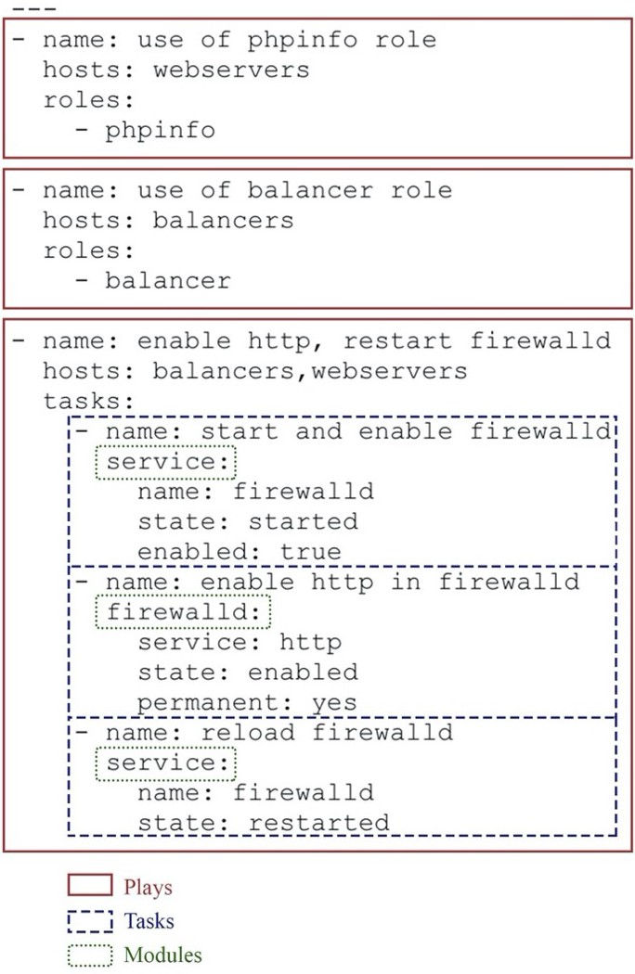

* + 1. Ansible Roles

Roles are directories containing well developed playbooks that are ready to use. The repository of roles is called Ansible Galaxy. People can also develop their own roles for special scenarios.

* + 1. Ansible Template File

Template File is in Jinja2 format, which is the template system that supports variables, conditions, and other basic syntax like loops.

* + 1. Ansible Handlers

Handlers is a yaml file that gets called when certain tasks are fulfilled. A common example of usage of handlers is to ensure services are reloaded or restarted when needed.

### Docker

Docker is an open platform for developing, shipping, and running applications. It enables users to separate applications from infrastructure so software could be delivered quickly (Docker, 2020). The key concepts of Docker – containers, images, and repositories are explained below.

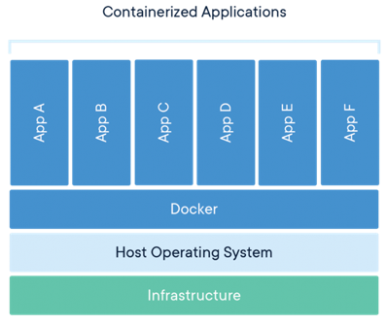

* + 1. Docker Container

Containers isolate software from its environment and ensure it works uniformly despite the differences between development and staging. In other words, the container is software packaged into standardized units for further development, shipment, and deployment. Compared to virtual machines, containers are more portable and efficient. The Hyperledger Fabric community publishes stable and tested Docker images to make deployment easier.

*Figure 2.5* Schematic Diagram of Containerized Applications3

3 Adapted from “What is a Container? | App Containerization | Docker,” by Docker Inc. Copyright 2020

* + 1. Docker Image

Docker images are modulated templates that could be used to produce container instances repetitively in no time. For example, a docker image could contain a MySQL service, a Zabbix monitoring service, or an Ubuntu operating system.

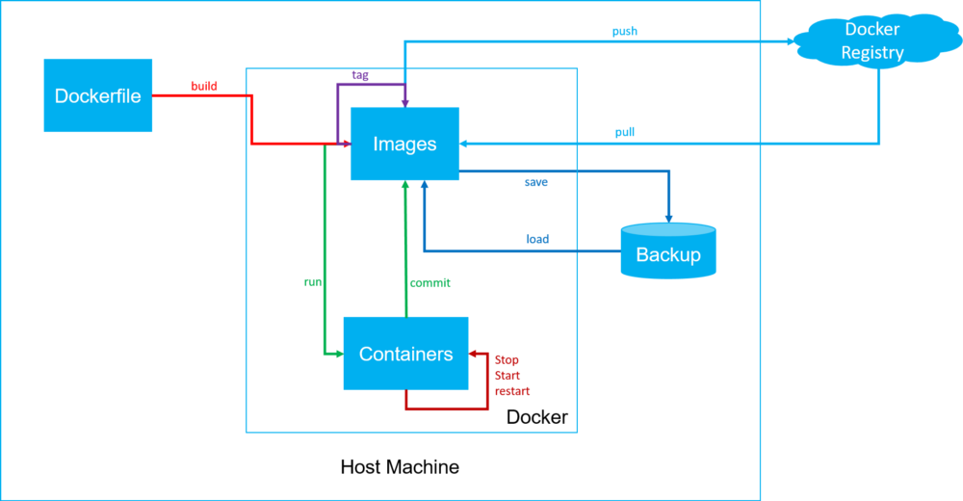

On top of well-composed docker images which are ready to use and open to public, people could also easily compose their own docker file to stack up images they want to run. Another important point to notice about docker image is that it is a read-only file. Any changes to a container instance will be saved as an ephemeral file on the top layer.

*Figure 2.6* Relations between Images, Registries, and Docker Files4

by “Docker Inc.”, https://[www.docker.com/resources/what-container,](http://www.docker.com/resources/what-container) on 6/14/2020.

4 Adapted from “ 認識 Docker. 高效能輕量級虛擬化工具,” by 黃冠融, May 23, 2020, https://mybaseball52.medium.com/meet-the-docker-7964506893a6, on 7/25/2020.

* + 1. Docker Repository

Repositories are where the docker images are kept, which are stored in registries. Currently, the largest public docker registry is Docker Hub, which is really similar to Github.

To explain the relations between containers, images, and repositories more clearly, we could see it as this example. Imagine we work at a bakery. Docker images are like cookie cutters, we cut (create container instances) and bake (ephemeral file) dough into cookies (docker containers). Last but not least, we store all our cookie cutters in drawers (docker repositories), and there are many drawers in the kitchen we work in (registries).

### DApp User Interface

Unlike typical centralized applications, decentralized applications (DApp) tend to be more flexible, and transparent. A DApp usually contains three main parts – chaincode (or smart contracts), web user interface, and data storage.

Chaincodes define the transaction rules, states, and computation. The role of chaincodes could be view as the server part of a typical centralized application.

The user interface part of the DApp is not too different from the typical user interfaces of a typical centralized application, this allows developers of DApp user interface to develop with frontend tools they are familiar with, such as HTML, CSS, and JavaScript. The actual interaction between DApp and the user interface are usually done by browser itself (like MIST or Metamasks browser). Although it is also possible to create a mobile DApp, with the lack of light-weighted key management tools, there are still no best practices of frontend mobile decentralized applications.

Most of the DApps store their static assets on decentralized storages such as IPFS or Swarm.

### HAproxy

High Availability Proxy (HAproxy) is formed by a single-thread, event-driven, and non-congestion engine, together with a fast I/O layer. Once a HAproxy is started, it is in charge of three things – dealing with received client connections, routinely checking the state of servers, and exchanging data with other HAproxy. It could be used for listening to TCP connections on sockets, be a HTTP gateway, an SSL terminal, a load balancer, a traffic regulator, and an examine node for network analyzation. HAproxy could also prevent DDoS attacks and service abuse.

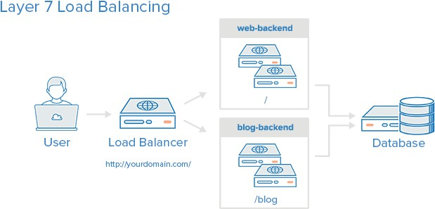

*Figure 2.7* An Example of Load Balancing5

5 Adapted from “HAProxy 和 负 载 均 衡 概 念 介 绍 ,” 2016, https://blog.csdn.net/napolunyishi/article/details/50455896, on 8/31/2020.

### Design Science Research

In the field of Information Systems at present, research can be roughly divided into two major forms - behavioral science and design science. The main differences between the two are based on the traits of research purposes and solutions to them. The former uses existing knowledge or technology (such as models and methods) to solve problems while the latter uses fairly unique or creative means. Furthermore, design science is associated with the creation of new artifacts (Goldkuhl, 2017) which should follow the seven guidelines shown in the table below as in (A. R. Hevner, S. T. March, J. Park, S. Ram, 2004).

Table 2.2 *Design-Science Research Guidelines*

|  |  |  |
| --- | --- | --- |
| **Guideline** | | **Description** |
| 1 | Design as an Artifact | Design-science research must produce a viable artifact in the form of a construct, a model, a method, or an instantiation. |
| 2 | Problem Relevance | The objective of design-science research is to develop technology-based solutions to important and relevant business problems. |
| 3 | Design Evaluation | The utility, quality, and efficacy of a design artifact must be rigorously demonstrated via well-executed evaluation methods. |
| 4 | Research Contributions | Effective design-science research must provide clear and verifiable contributions in the areas of the design artifact, design foundations, and/or design methodologies. |
| 5 | Research Rigor | Design-science research relies upon the application of rigorous methods in both the construction and evaluation of the design artifact. |
| 6 | Design as a Search Process | The search for an effective artifact requires utilizing available means to reach desired ends while satisfying laws in the problem environment. |
| 7 | Communication of Research | Design-science research must be presented effectively both to technology-oriented as well as management-oriented audiences. |

# Chapter 3 Research Methods

The present paper follows the seven design science research (DSR) guidelines, composing a reusable Ansible playbook for automating DApp server setup and configuration. This section also includes the testing environment setup and explains the evaluation and monitoring tools for evaluating the performance.

### Design of the Structure

The design of the present paper follows the seven guidelines of the design science research introduced in the previous chapter.

The present paper produces a reusable Ansible playbook for setting up and configuring servers for short term events, which follows the first and the fourth guidelines of creating an artifact. The purpose for the present paper is to find a technology-based solution to reduce the waste of resources and time during each short- term event, trying to solve an existing business problem with an effective artifact, complying with the second and the sixth guidelines. The state of the servers is monitored and the time consumptions of a full run of the Ansible playbook is recorded, following the third and the fifth guidelines.

Last, the seventh guideline is met by evaluating the server with benchmarking tools after setup.

### Experiment Testbed Architecture

The experiment testbed architecture of the present paper is shown as below. The architecture contains one Ansible control node (workstation), a HAproxy as a Load-

balancer (hostb), two webservers (hostc, hostd) serve for webUI, and one Zabbix Server. There is also a backup test machine (hosta). The OS of all the hosts are CentOS 8.2. The version of Ansible installed is 2.9. All of the hosts are virtual machines configured with 4 core CPUs and 16G RAMs.

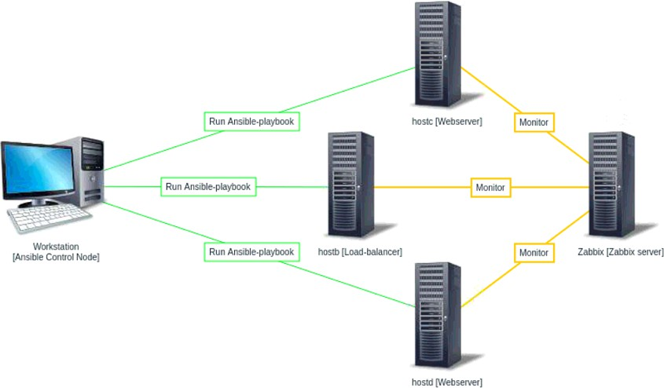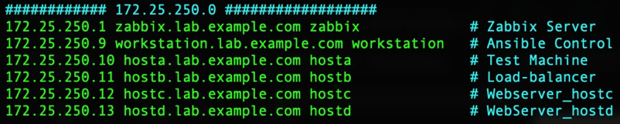

*Figure 3.1* The Testbed Architecture of Experiment

*Figure 3.2* Information of the Experiment Testbed Architecture

The Ansible Control Node runs ansible-playbook in order to setup the load- balancer and webservers, as long as installing all the requiring packages and finishing all the configurations needed. Hostb is planned to serve as a HAProxy server for Load-

balancing purpose. Hostc and hostd are webservers that provide the Web User Interface for customers to interact with the Hyperledger Fabric Network through SDKs and APIs.

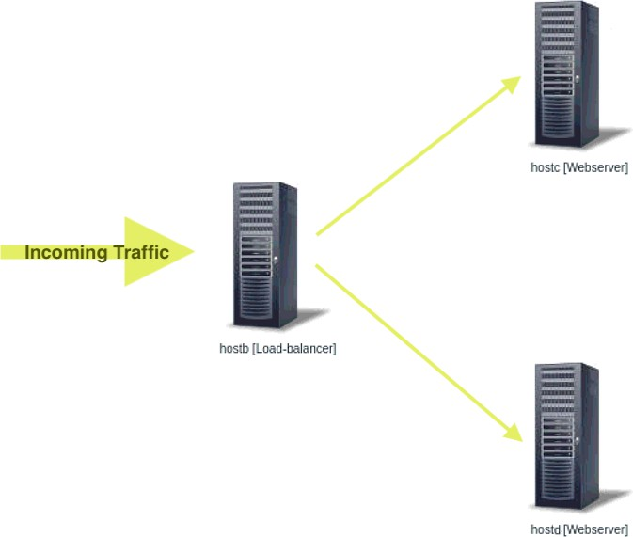

*Figure 3.3* The Experiment Testbed Load-balancing Architecture

### Evaluation Tool

The present paper uses Apache Benchmarking Tool provided by Apache Foundation as the main tool to evaluate the performance of the webserver with and without a Load-balancer. In this section, basic knowledge of Service Level Indicator and Service Level Objective are also included.

* + 1. Service Level Indicator

Service Level Indicator (SLI) is the indicator for the quality of services on servers. Latency is one of the most critical SLIs for most of the services. Other often used SLIs such as error rate (percentage of failed requests), and system throughput (requests per second) are normally calculated data. Availability and durability are also important SLIs when it comes to server monitoring.

* + 1. Service Level Objective

Service Level Objective (SLO) is the target value (or range) for a certain SLIs of a server. It is a complex process to choose a suitable SLO for service. A simple definition of SLO can be illustrated as the two equations: *SLI <= target value. lower bounds <= SLI <= upper bound.* Adapted from (B. Beyer, C. Jones, J. Petoff, N. R. Murphy, 2016).

* + 1. Apache Benchmarking

Apache Benchmarking tool (AB) is a tool for benchmarking Apache HTTP Servers. With Apache Benchmarking tool, you could get information such as how many requests per second your web service is capable of serving.

*Figure 3.4* Example Output of Apache Benchmarking Tool

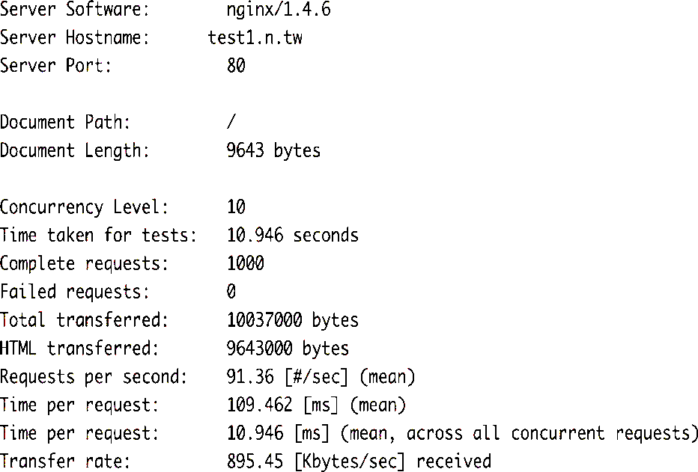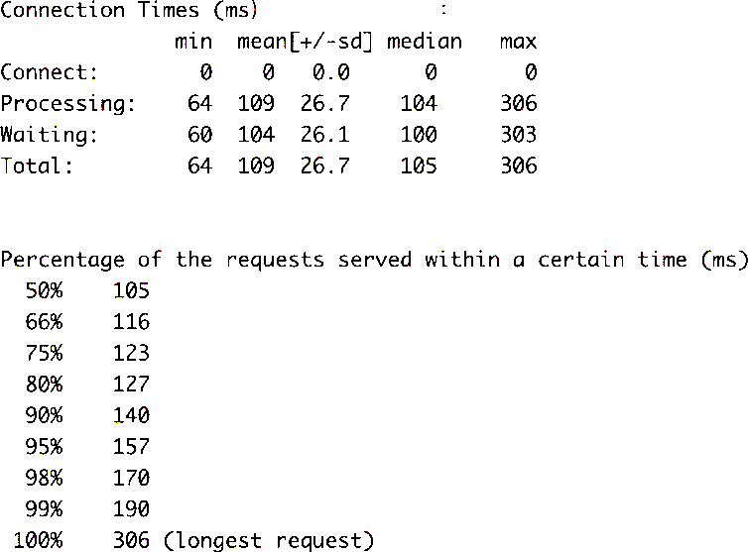

### Monitoring Tool

The present paper sets up a Zabbix server for monitoring. Zabbix is an open-source monitoring system for monitoring the states of machines. A Zabbix server is set up and configured with Telegram alerts. The objectives (SLO) of the present paper and some critical indicators that need to be monitored are also include in this chapter.

Four types of critical SLIs that should be monitored are as below:

* + 1. Latency

It is important to monitor the latency for errors like HTTP 500 to be resolved.

* + 1. Throughput

This SLIs can be the HTTP requests per second for web servers yet it can also be the I/O rate for music streaming platforms.

* + 1. Error rate

This SLIs is different from HTTP 500 error. It can be either HTTP 200 with the wrong content or timeout. Usually, this indicator could only be discovered by end systems.

* + 1. Saturation

Saturation is a SLIs which is the most limited to the resource. Since the efficacy of many services would be overwhelmed once the usage reach 100%, it is extremely important to monitor the utilization of the system.

*Figure 3.5* Dashboard of the Zabbix Server

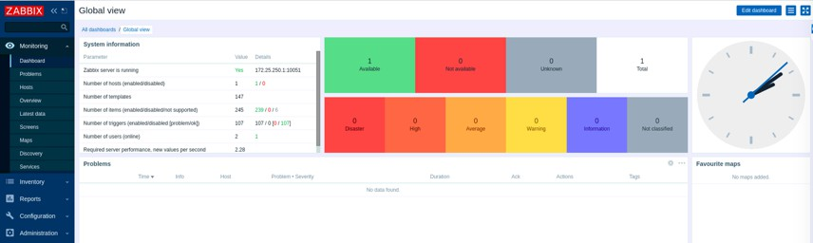

Generally speaking, the data distribution of the monitored systems is more long tail distribution than the normal distribution. It is important to recognize what kind of data distribution the collected data has when it comes to SLI normalization. In order to reduce cost, it is necessary to setup a reusable standardized template for SLIs. The following template example is provided by Google (B. Beyer, C. Jones, J. Petoff, N. R. Murphy, 2016):

* + - * Collection interval: 1 minutes.
      * Range: all the tasks in the cluster.
      * Update frequency: 10 seconds.
      * Request: all the black-box monitoring tasks.
      * Method: collecting data from the monitoring server.
      * Latency: time between receiving data to the last byte sent.

According to the Tourism Bureau of Taiwan, a total amount of 376,773 visitors visited the Taipei International Travel Fair (ITF) throughout the entire six-day event in 2019, meaning approximately 62,795 visitors per day according to (Taiwan Visitors Association, 2019). The present paper aims to set up DApp servers that would be able to meet this number of requests.



# Chapter 4 Results

The result of the present paper contains the setup of a Zabbix Monitoring server to monitor the state of webservers and the load-balancer, the designed Ansible playbooks for setting up webservers, load-balancer, and installing Zabbix agent for monitoring. Server evaluation and state are also included in this chapter.

### Server Monitoring

As described in the previous chapter, a Zabbix monitoring server with access to send Telegram alerts is set up to monitor the state of the webservers and the load- balancer.

* + 1. Telegram Alerts

Since the current version of Zabbix has not yet come with a built-in function to send alerts with graphs, users will need to try out their own ways to get a more intuitive alert message. Along with the present paper, we composed scripts for the Zabbix server to store the graph of the item that triggers the alert, and then send it with the alert message. Once an alert is triggered, the Zabbix Server runs scripts to send alerts to Telegram through a chat bot. An example of the alert message with the graph sent through chat bot into a Telegram group is shown below:

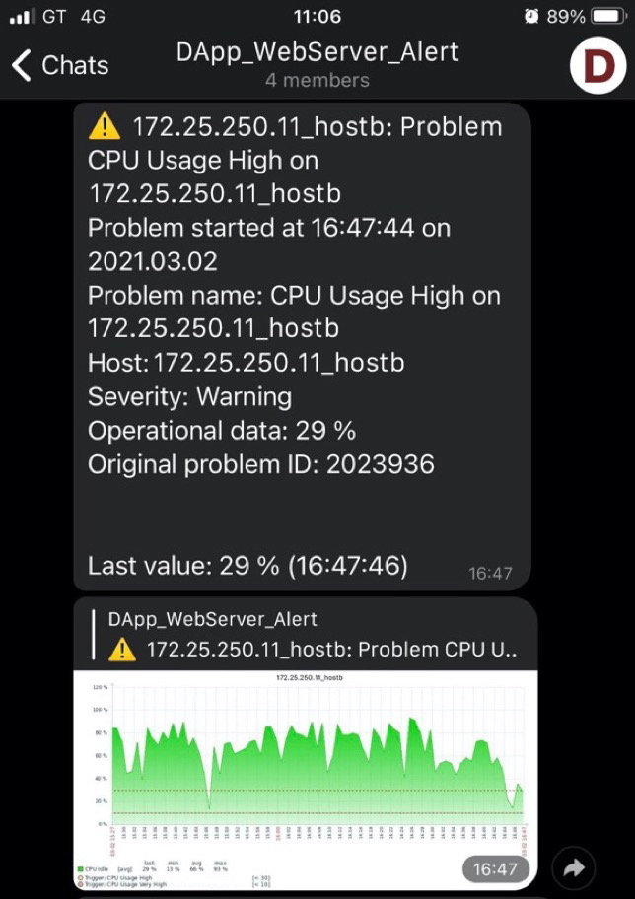

*Figure 4.1* Example of the Telegram Alert

* + 1. State Monitoring

The states of each webserver and load-balancer are rigorously monitored throughout the entire evaluation period. Once the current webservers reach the SLOs, Zabbix server sends alerts to the user and simultaneously triggers the configured shell script to run Ansible playbook to set up a new webserver and add it to the load- balancing server farm.

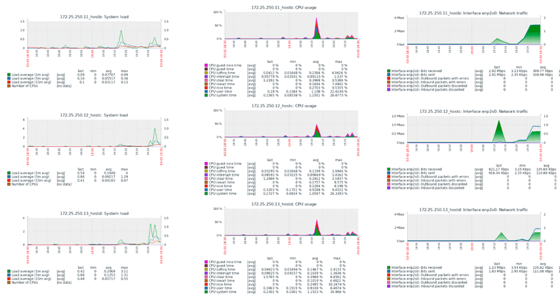

*Figure 4.2* The State of Existing Webservers and the Load-balancer

### Designed Ansible Playbook

The present paper designs an Ansible playbook to quickly setup and configure DApp user interface servers and set up a webserver. Another Ansible playbook is also designed to install and configure Zabbix agent on the servers. With the combination of two, users can easily setup and add a new machine into the load-balancing server farm and add it on to the Zabbix monitoring server for future monitoring.

* + 1. Structure of the Designed Ansible Playbook

The structure of the designed Ansible playbook is shown as *Figure 4.5*. The specified configurations of running the Ansible playbook is stated in the “ansible.cfg” file. The file specifies everything relevant to the Ansible run, including the remote users, privilege escalation details, and all the paths to the files.

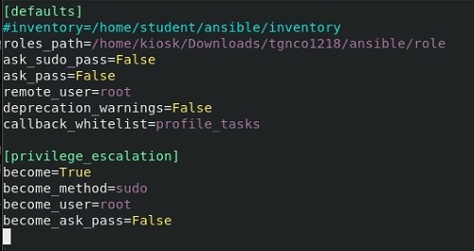

*Figure 4.3* The Ansible Configuration File

The files “installZabbixAgent.yml” and “prepHAproxyAndWebservers.yml” will be explained later in this chapter. The “newWebserver.sh” file is executed by Zabbix server when any of the SLOs on either of the existed webservers is reached during the evaluation period. The shell script first writes the information of a new machine (such as: hostname, IP address) into the Ansible inventory file. After that, the script executes commands to re-run the Ansible playbooks. Because Ansible is a desired state engine as we discussed in chapter two, the run wouldn’t affect any of the existing webservers and the load-balancer, yet it will set up and configure the new machine and update the configuration file of the load-balancer to add the new machine into the server farm.

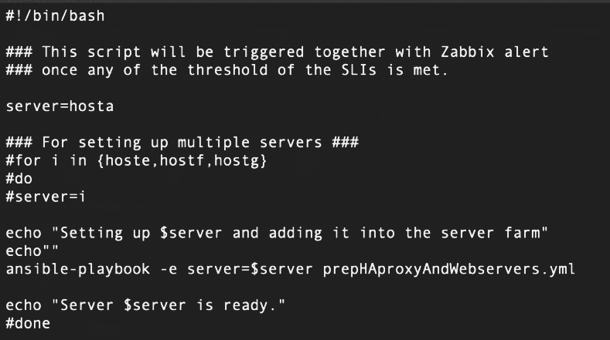

*Figure 4.4* The Shell Script “newWebserver.sh”

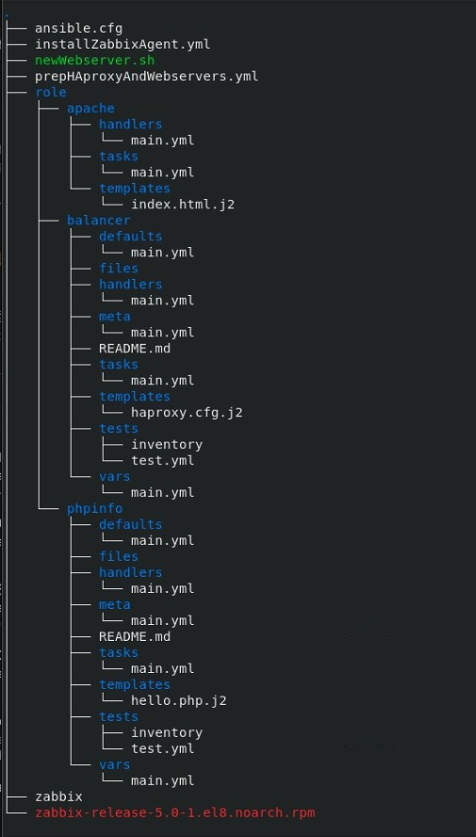

*Figure 4.5* The Structure of the Designed Ansible Playbook

* + 1. Designed Ansible Playbooks

The first Ansible playbook “prepHAproxyAndWebservers.yml” is designed to set up the original webservers and a load-balancer. The content of the playbook is shown as *Figure 4.8*. After the full run of the playbook, hostc and hostd is configured and ready to access as webservers, which can be verified using the curl tool below:

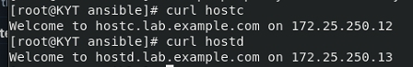

*Figure 4.6* The Results of Curl Hostc and Hostd

It can also be verified with the curl tool that hostb is setup as a load-balancer and is distributing the traffics evenly to hostc and hostd as the graph below:

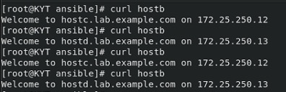

*Figure* *4.7* The Results of Curl Hostb

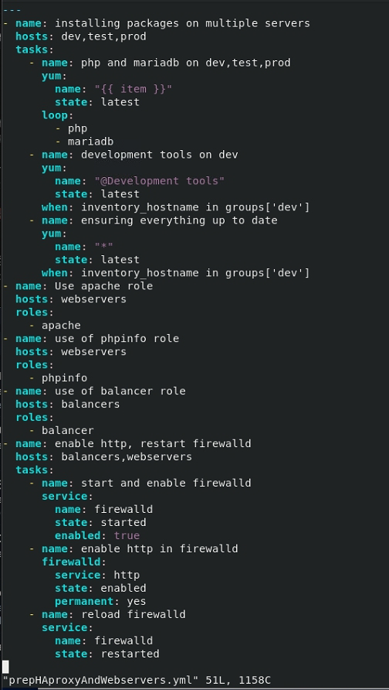

*Figure 4.8* The Content of Ansible Playbook “prepHAproxyAndWebservers.yml”

The second Ansible playbook “installZabbixAgent.yml” installs and configures Zabbix agent on the new machine added to the Ansible inventory file. As discussed earlier, playbook has no effects on the existing servers that already meet the desired state stated in the playbook. The playbook first examines what OS version is run on the new machine, then installs and configures the relevant version of Zabbix agent onto the machine. The content of the playbook is shown as below:

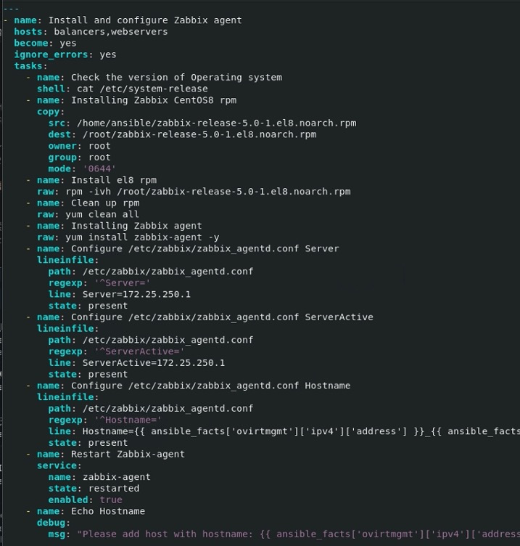

*Figure* *4.9* The Content of Ansible Playbook “installZabbixAgent.yml”

### Evaluation

With a well configured Ansible playbook and shell scripts, it took only approximately 36.279 seconds to set up the original structure with two servers and one load-balancer, 2 minutes and 26.484 seconds to install Zabbix on two webservers and the load-balancer, and 41.845 seconds to set up a backup server once the threshold of SLIs on any of the servers is reached.

The graph below shows a test result of two servers completing 62,800 requests with 1,000 hits at a time. The longest request took about 3.658 seconds to complete. The entire test took approximately 10.283 seconds to finish.

We could see that the designed structure could easily hold up to the numbers of visitors to the travel affairs with only two servers in the load-balancer’s server farm by evaluations through Apache benchmarking tools. If multiple events with the same size happen at the same time, it is also easy to set up more servers.

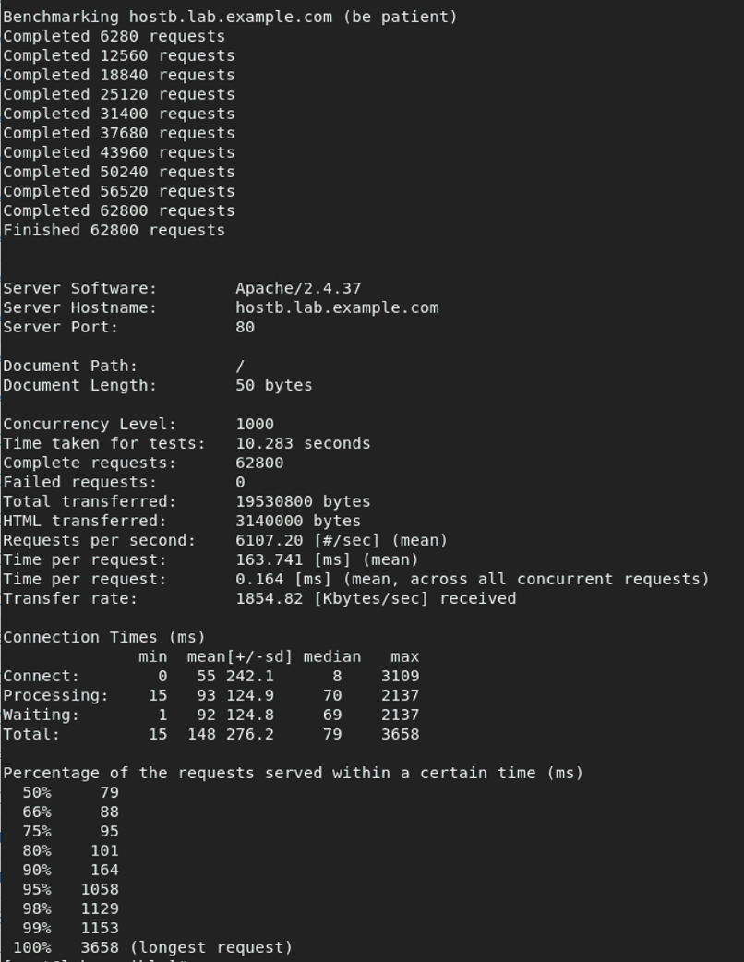

*Figure 4.10* The Evaluation of the Web Servers

To get more an accurate result, we did the evaluation tests 30 times with the two servers completing 62,800 requests with 1,000 hits at a time. The state of the servers was monitored the whole time to get the possible SLOs for alert configuration later on. The testing results could be found in Table three below.

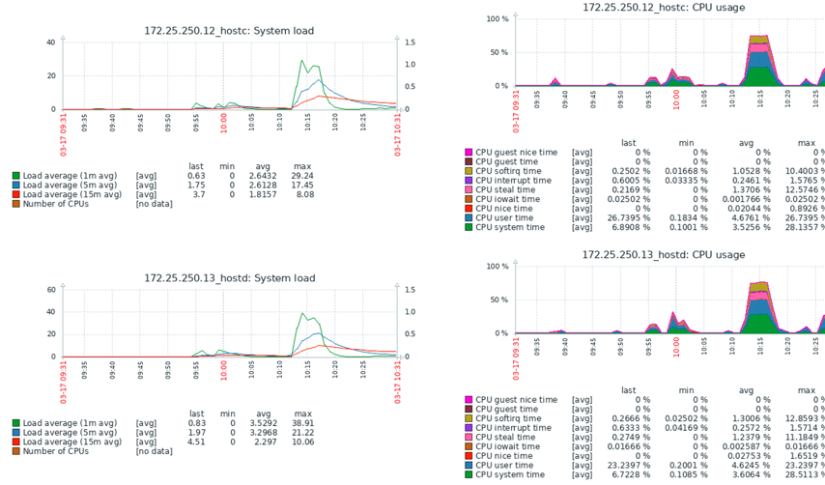

*Figure 4.11* The State of Servers while Operating Evaluation Testing

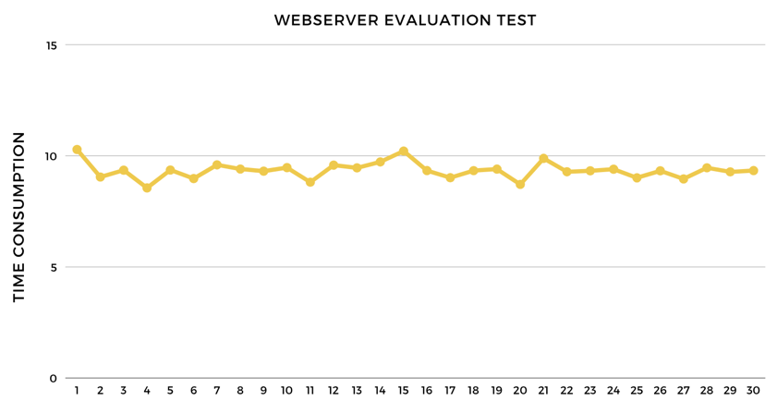

*Figure 4.12* The Time Consumption of 30 Evaluation Tests

Table 4.1 *Results of Two Webservers Completing 62,800 Requests with 1,000 Hits*

|  |  |  |  |  |
| --- | --- | --- | --- | --- |
|  | **Time Consumption (s)** | **Longest Requests (s)** | **99% of Requests Finished in (s)** | **95% of Requests Finished in (s)** |
| 1 | 10.283 | 3.658 | 1.157 | 1.099 |
| 2 | 9.046 | 3.188 | 1.151 | 0.421 |
| 3 | 9.353 | 3.445 | 1.148 | 0.396 |
| 4 | 8.555 | 3.368 | 1.328 | 0.517 |
| 5 | 9.362 | 3.185 | 1.148 | 1.029 |
| 6 | 8.976 | 3.129 | 1.151 | 0.376 |
| 7 | 9.593 | 3.381 | 1.144 | 0.353 |
| 8 | 9.406 | 3.209 | 1.138 | 0.323 |
| 9 | 9.309 | 3.242 | 1.156 | 0.331 |
| 10 | 9.468 | 3.382 | 1.13 | 0.317 |
| 11 | 8.813 | 3.213 | 1.156 | 0.373 |
| 12 | 9.582 | 3.176 | 1.165 | 0.514 |
| 13 | 9.457 | 2.22 | 1.145 | 0.408 |
| 14 | 9.726 | 3.231 | 1.164 | 0.481 |
| 15 | 10.214 | 2.661 | 1.137 | 0.384 |
| 16 | 9.335 | 2.338 | 1.134 | 0.353 |
| 17 | 9.015 | 3.139 | 1.128 | 0.338 |
| 18 | 9.334 | 3.615 | 1.142 | 0.368 |
| 19 | 9.401 | 3.409 | 1.141 | 0.389 |
| 20 | 8.714 | 3.224 | 1.134 | 0.359 |
| 21 | 9.883 | 2.208 | 1.137 | 0.328 |
| 22 | 9.283 | 3.153 | 1.145 | 0.397 |
| 23 | 9.327 | 7.149 | 1.296 | 0.464 |
| 24 | 9.399 | 3.167 | 1.139 | 0.389 |
| 25 | 9.011 | 3.594 | 1.141 | 0.385 |
| 26 | 9.324 | 3.193 | 1.14 | 0.342 |
| 27 | 8.961 | 3.196 | 1.137 | 0.356 |
| 28 | 9.461 | 3.23 | 1.145 | 0.382 |
| 29 | 9.278 | 3.471 | 1.138 | 0.379 |
| 30 | 9.335 | 3.136 | 1.137 | 0.384 |

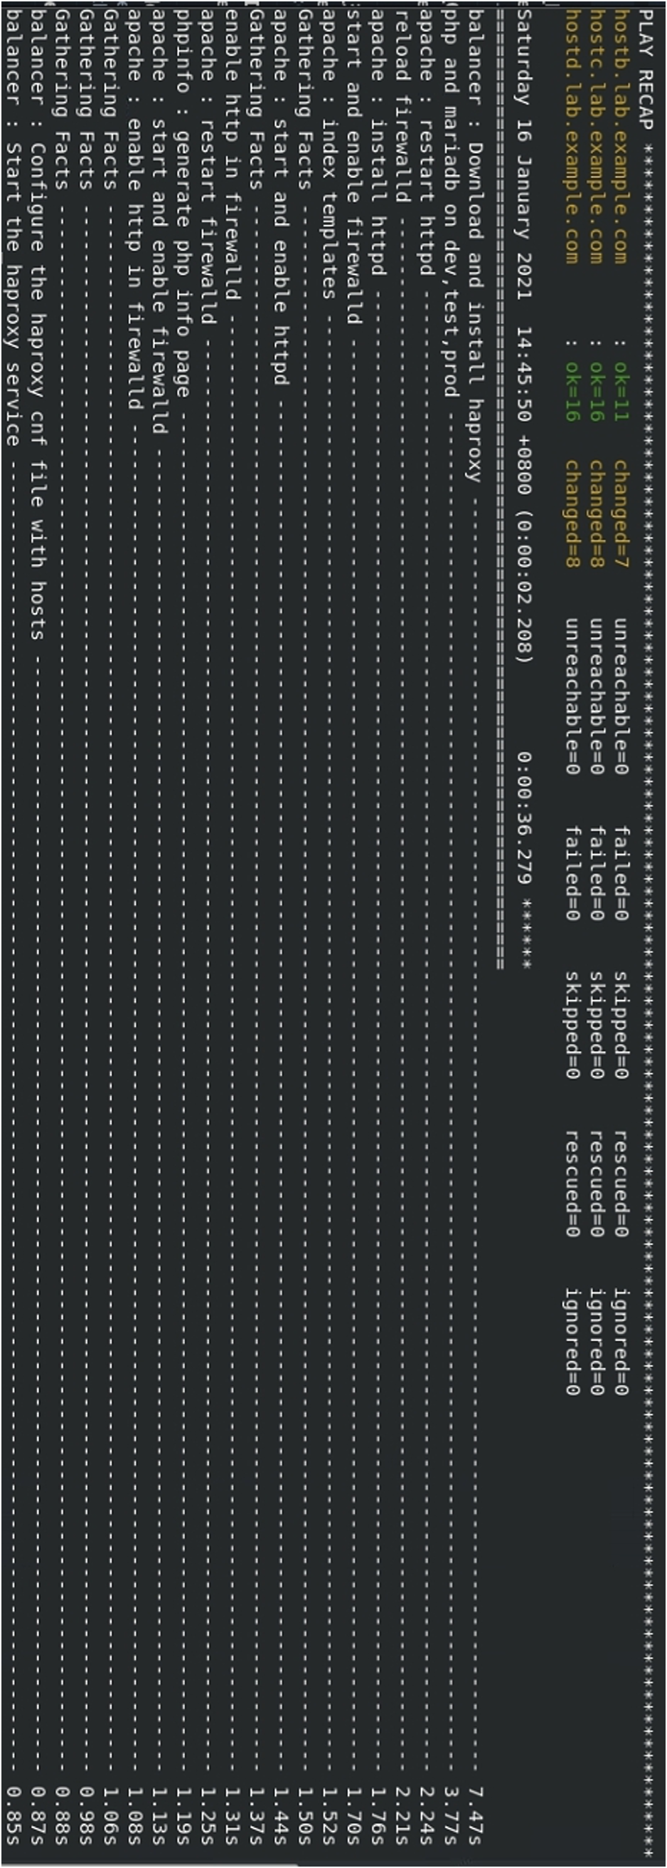

*Figure 4.13* The Full Run of Ansible Playbook “prepHAproxyAndWebservers.yml”

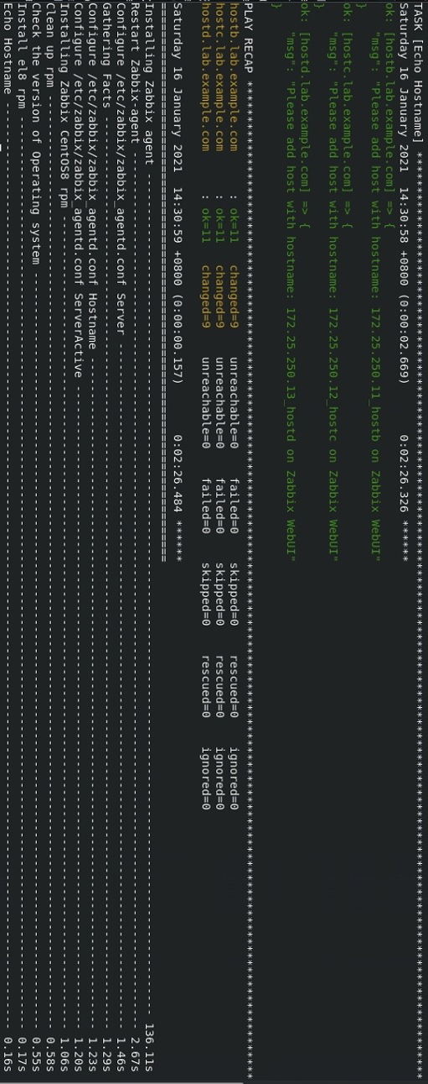

*Figure 4.14* The Full Run of Ansible Playbook “installZabbixAgent.yml”

Once either one of the current webservers reaches the threshold of the SLIs, the Ansible playbook “prepHAproxyAndWebservers.yml” is triggered by Zabbix server. The full run to setup a new machine and add it to the server farm takes approximately 41.845 seconds to rerun the playbook with a new host added into the server group.

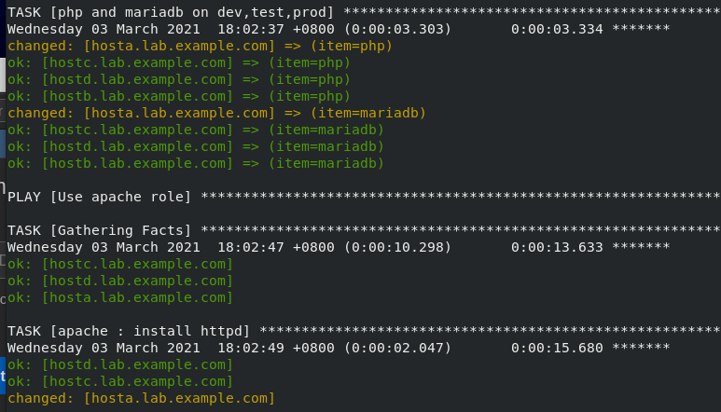

*Figure* 4.15 Host Remains Unchanged if It Already Meets the Desired State

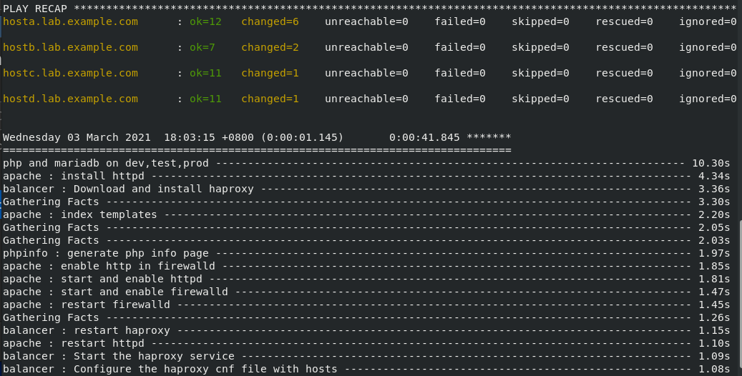

*Figure 4.16* The Full Run of Ansible Playbook to Set-up a New Webserver

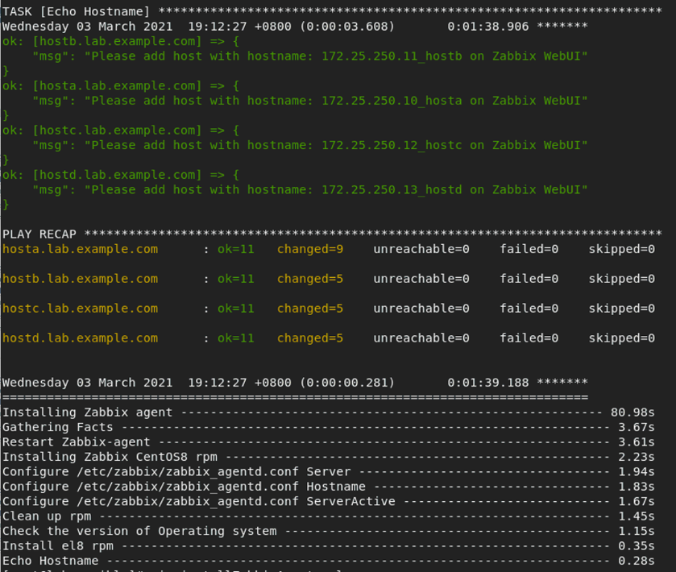

*Figure 4.17* Installing Zabbix Agent on the Newly Configured Server

The architecture with the new server hosta added into the load-balancing server farm is shown as *Figure 4.18* below. We also record the time consumption for joining a backup server in to the production server farm in Table four.

Since the present paper aim to solve an existed business waste problem for a short- term events, the automation of scaling down servers is not considered. This thesis assumes once the SLO was met and the alert is triggered, administrators will be informed and do the neccesary changes to the servers. The scaling down process could be easily performed with another Ansible playbook to reset the server to a clean state and removed from the server farm, which is not covered in this thesis.

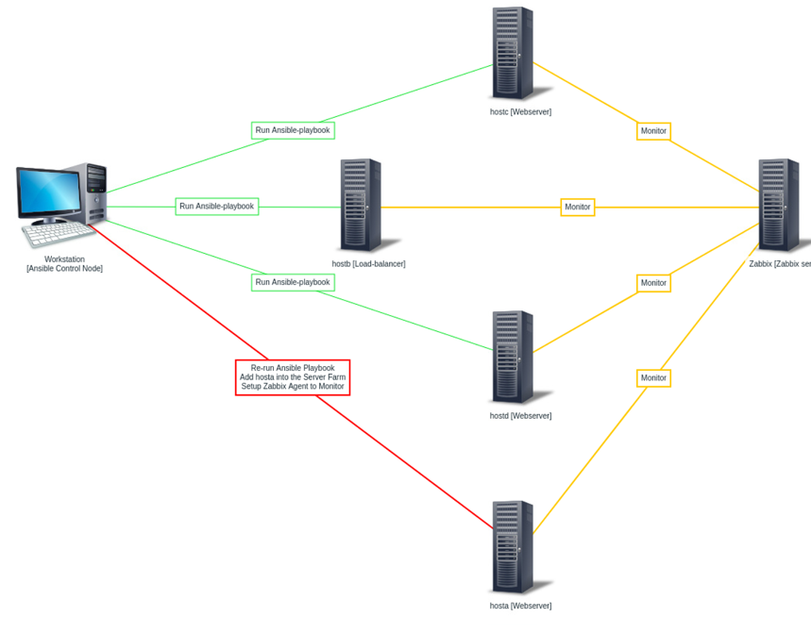

*Figure 4.18* The New Test-bed Architecture after Adding in Hosta

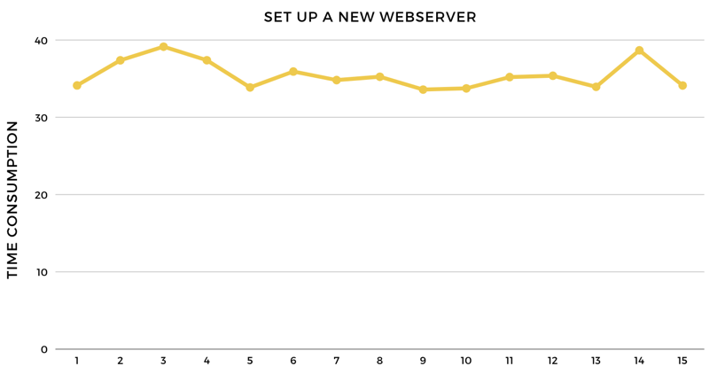

*Figure 4.19* The Time Consumption of Setting up a New Webserver

Table 4.2 *Time Consumption for Setting up a New Server*

|  |  |  |
| --- | --- | --- |
|  | **Setup a New Webserver (s)** | **Install Zabbix Agent on the New Server (s)** |
| 1 | 34.122 | 14.664 |
| 2 | 37.373 | 12.27 |
| 3 | 39.139 | 12.273 |
| 4 | 37.382 | 12.507 |
| 5 | 33.865 | 12.106 |
| 6 | 35.923 | 12.114 |
| 7 | 34.815 | 11.301 |
| 8 | 35.247 | 11.491 |
| 9 | 33.588 | 13.231 |
| 10 | 33.741 | 11.62 |
| 11 | 35.202 | 12.232 |
| 12 | 35.375 | 11.746 |
| 13 | 33.94 | 12.639 |
| 14 | 38.666 | 12.776 |
| 15 | 34.112 | 11.45 |



# Chapter 5 Conclusion

The present paper walks through many related topics such as Blockchain, Ansible, Docker, DApp, HAproxy, and design science research. The designed structure of the present paper follows the seven guidelines of design science research, experiment testbed, and evaluation and monitoring tools are also introduced. The results of the present paper include a designed Ansible playbook for setting up servers which takes approximately 37 seconds, a shell script that triggers the playbook that would setup another server to join the load-balancing server farm within 42 seconds, and a Zabbix monitoring server that can send both Telegram and email alerts with graphs.

Please note that the time used for developing and testing the DApp user interface, configuring Ansible remote users on each machine, and the setup of the Zabbix monitoring server is not recorded above, and the time required for a full run of the Ansible playbook depends on the speed of the internet, program dependencies, and the state of the servers. The designed Ansible playbook could be reused by simply modifying some parts such as the information of servers, the paths of the files to the DApp user interface, and the program dependencies.

The present paper aims for creating an Ansible playbook prototype for setting up and configure the servers for short-term events. Therefore, the present paper uses the Taipei International Travel Fair in 2019 as an example to design the playbook since it has a more integrated data. The possible future work directions could be fine-tuning the created Ansible playbook to suit the needs of other short-term events.

The determine of responsibility of humans and machines is shown in Table 5.1 as below. The human is responsible for setting up the original servers, configure the Ansible playbooks, and decide the SLOs based on the monitoring results while the

machine is in charge of making human’s life easier by monitoring the servers, and sending alerts and scale up in case of emergency.

Table 5.1 *Responsibility Determination between Human and Machine*

|  |  |  |
| --- | --- | --- |
| Label  Responsibility | **Human** | **Machine** |
| Setup Original Server Farms | √ |  |
| Add to Monitoring Targets | √ |  |
| Monitoring Servers |  | √ |
| Setup SLOs Based on Monitoring Results | √ |  |
| Configure Alerts and Define Triggers | √ |  |
| Send Alert Message in Case of Emergency |  | √ |
| Scale up in Case of Emergency |  | √ |
| Evaluation | √ |  |
| Scale down | √ |  |

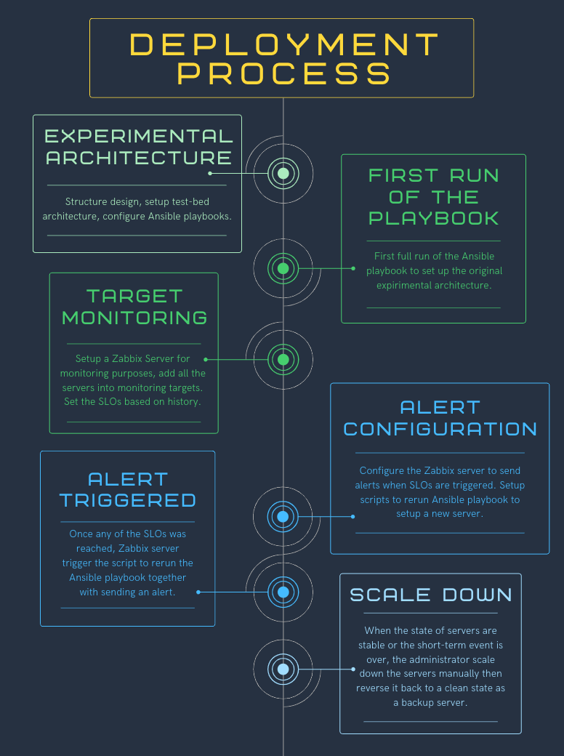

*Figure 5.1* Deployment Process

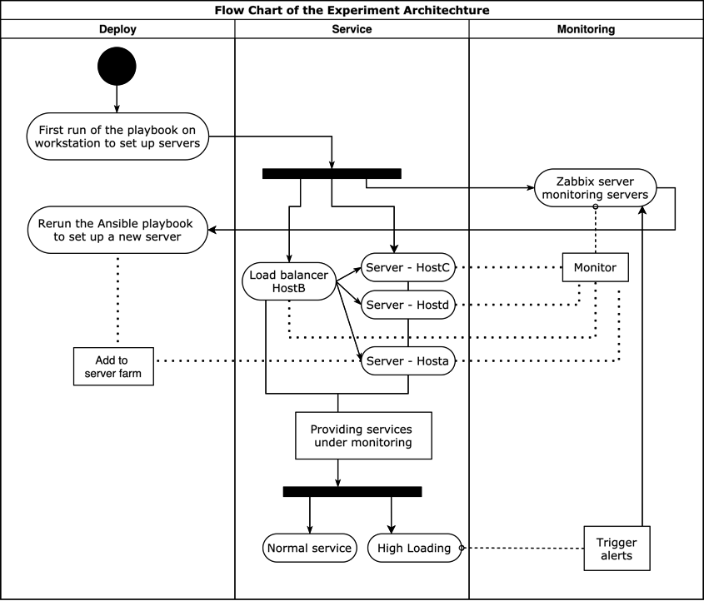

*Figure 5.2* Flow Chart of the Experimental Architecture

# References



1. Hyperledger. (2020, Oct. 3.). A blockchain platform for the enterprise—hyperledger- fabricdocs master documentation. Retrieved from https://hyperledger-fabric.readthedocs.io/en/release-2.2/
2. Bennett, K. (2019, Oct. 3.). Hyperledger Fabric 1.4: key concepts training. Retrieved from https://blockchaintrainingalliance.com/blogs/news/hyperledger-fabric-1-4-key- concepts
3. Hyperledger. (2020, Oct. 3.). Glossary—hyperledger-fabricdocs master documentation.

Retrieved from https://hyperledger-fabric.readthedocs.io/en/release- 2.2/glossary.html.

1. Red-Hat. (2020, Oct. 3.). Ansible Documentation. Retrieved from https://docs.ansible.com/
2. Geerling, J. (2015). *Ansible for DevOps.不夠完整 但由於沒有其他資訊我無法判斷這個文獻型態*
3. Docker. (2020, Oct. 3.). Docker overview | Docker Documentation. Retrieved from https://docs.docker.com/engine/
4. Goldkuhl, G. (2017). Separation or unity? Behavioral science vs. design science.
5. Hevner, A. R., March, S. T., Park, J., and Ram, S. (2004). Design science in information systems research. *不夠完整 查不到或無法判斷型態*
6. Hochstein, L., Moser, R.(2015). *Ansible: Up and Running: Automating Configuration Management and Deployment the Easy Way. 不夠完整 查不到 無法判斷型態*
7. Gorenflo, C., Lee, S., Golab, L. and Keshav, S. (2019). “FastFabric: Scaling Hyperledger Fabric to 20,000 Transactions per Second,” *IEEE International Conference on Blockchain and Cryptocurrency (ICBC)*, vol.3, pp. 455-463, Nov. 2019.
8. Beyer, B., Jones C., Petoff, J. and Murphy, N. R. (2016). “*Site Reliability Engineering: How Google Runs Production Systems,*” O'Reilly Media, Inc.

